|  |
| --- |
| PROJECT DOCUMENTATION |

Project

Movie Recommendation System Using Machine Learning

Project Started Date – 04/09/2023

Revision Number - 1

Project Submitted by – KISHORE DEVARAGUDI

Project Submitted to – NEWBIERON TECHNOLOGIES

|  |
| --- |
| ARCHITECTURE |

1. **Introduction**
   * Purpose
     + - Scope
       - Audience

**2.Overview**

* What is a Movie Recommendation System?
* Importance of Movie Recommendation Systems
* Types of Recommendation Systems
* System Architecture

**3. Data Collection**

* Data Preprocessing
* Feature Engineering
* Machine Learning Algorithms
* Evaluation Metrics

**4. Data Collection**

* Data Sources
* Data Extraction
* Data Cleaning
* Data Integration

**5. Data Preprocessing**

* Data Transformation
* Data Normalization
* Data Splitting

**6. Feature Engineering**

* User Profile Creation
* Movie Profile Creation
* Collaborative Filtering
* Content-Based Filtering

**7. Machine Learning Algorithms**

* Collaborative Filtering Algorithms
* Content-Based Filtering Algorithms
* Hybrid Models
* Deep Learning Approaches
* Model Training

**8. Evaluation Metrics**

* Accuracy
* Precision
* Recall
* F1 Score
* Mean Absolute Error (MAE)
* Root Mean Square Error (RMSE)
* Deployment

**9. Web Application**

* Web Application
* API Integration
* Maintenance and Updates

**10. Monitoring**

* Monitoring
* Data Updates
* Model Retraining

**11. Security and Privacy**

* Data Security
* User Privacy

**12. Conclusion**

* Summary of the Project
* Future Enhancements

**13. References**

**1. Introduction**

1.1 Purpose

The purpose of this documentation is to provide a comprehensive guide to understanding and implementing a Movie Recommendation System Using Machine Learning techniques.

1.2 Scope

This documentation covers the entire development lifecycle of a Movie Recommendation System, from data collection to deployment. It also includes information about evaluation metrics, maintenance, security, and privacy considerations.

1.3 Audience

This documentation is intended for data scientists, machine learning engineers, developers, and anyone interested in building and deploying a movie recommendation system.

1. **Overview**

2.1 What is a Movie Recommendation System?

A Movie Recommendation System is a software application that suggests movies to users based on their preferences and behaviour. It utilizes machine learning algorithms to provide personalized movie recommendations.

2.2 Importance of Movie Recommendation Systems

Movie recommendation systems are crucial for content providers like streaming platforms as they enhance user engagement and satisfaction, leading to increased user retention and revenue.

2.3 Types of Recommendation Systems

There are primarily two types of recommendation systems: Collaborative Filtering and Content-Based Filtering. Hybrid systems that combine both approaches are also common.

**3. System Architecture**

3.1 Data Collection

This section outlines the process of gathering data, including sources, extraction, cleaning, and integration. Dataset is taken from Kaggle TMDB 5000 Movie [**TMDB 5000 Movie Dataset | Kaggle**](https://www.kaggle.com/datasets/tmdb/tmdb-movie-metadata?select=tmdb_5000_movies.csv)

3.2 Data Preprocessing

Here, we describe how to prepare the data for modelling, including transformations, normalization, and splitting.

3.3 Feature Engineering

Feature engineering involves creating user and movie profiles and implementing collaborative and content-based filtering.

3.4 Machine Learning Algorithms

This section covers various machine learning algorithms used for recommendation systems and how to train them.

3.5 Evaluation Metrics

We discuss the metrics used to evaluate the performance of recommendation models.

**4. Data Collection**

4.1 Data Sources

Explains where to obtain movie-related data, such as user ratings and movie details.

4.2 Data Extraction

Describes methods for extracting data from various sources, such as APIs and databases.

4.3 Data Cleaning

Covers data cleaning techniques to ensure data quality and consistency.

4.4 Data Integration

Discusses how to combine and integrate data from multiple sources.

**5. Data Preprocessing**

5.1 Data Transformation

Explains how to transform raw data into a suitable format for modelling.

5.2 Data Normalization

Describes the importance of normalizing data and provides normalization methods.

5.3 Data Splitting

Details the process of splitting data into training and testing sets.

**6. Feature Engineering**

6.1 User Profile Creation

Explains how to create user profiles based on their historical preferences.

6.2 Movie Profile Creation

Describes how to generate movie profiles using features like genre, director, and actors.

6.3 Collaborative Filtering

Covers collaborative filtering techniques, including user-based and item-based approaches.

6.4 Content-Based Filtering

Explains content-based filtering methods, which recommend items similar to those a user has liked.

**7. Machine Learning Algorithms**

7.1 Collaborative Filtering Algorithms

This section delves into collaborative filtering algorithms like User-Item Filtering and Matrix Factorization.

7.2 Content-Based Filtering Algorithms

Details various content-based filtering techniques, such as TF-IDF and neural networks.

7.3 Hybrid Models

Explains hybrid models that combine collaborative and content-based filtering for improved recommendations.

7.4 Deep Learning Approaches

Covers deep learning methods, including neural collaborative filtering and recurrent neural networks (RNNs).

7.5 Model Training

Describes the process of training recommendation models with prepared data.

**8. Evaluation Metrics**

8.1 Accuracy

Explains the concept of accuracy and its relevance for recommendation systems.

8.2 Precision

Describes precision as a metric to measure the relevance of recommended items.

8.3 Recall

Details recall as a measure of how many relevant items are recommended.

8.4 F1 Score

Introduces the F1 score, which balances precision and recall.

8.5 Mean Absolute Error (MAE)

Explains MAE as a metric to evaluate the performance of regression-based recommendation models.

8.6 Root Mean Square Error (RMSE)

Describes RMSE as an alternative metric for regression-based models.

**9. Deployment**

9.1 Web Application

Explains how to deploy the recommendation system in a web-based interface.

9.2 Mobile Application

Describes considerations for integrating recommendations into a mobile app.

9.3 API Integration

Covers the process of exposing recommendation functionality through APIs for third-party applications.

**10. Maintenance and Updates**

10.1 Monitoring

Details methods for monitoring system performance and user interactions.

10.2 Data Updates

Explains how to handle updates and changes in the underlying data.

10.3 Model Retraining

Describes the need for periodic model retraining to adapt to changing user preferences.

**11. Security and Privacy**

11.1 Data Security

Discusses methods to secure user data and prevent unauthorized access.

11.2 User Privacy

Explains how to protect user privacy while collecting and using their data for recommendations.

Code Details

GitHub link: [**https://github.com/Kishordevaragudi/Movie_Recommendation_system.git**](https://github.com/Kishordevaragudi/Movie_Recommendation_system.git)

app link: **https://movierecommendationsystem-kmbe8qxpqgou4stjbepemk.streamlit.app**

More details: <https://www.learndatasci.com/glossary/cosine-similarity/>

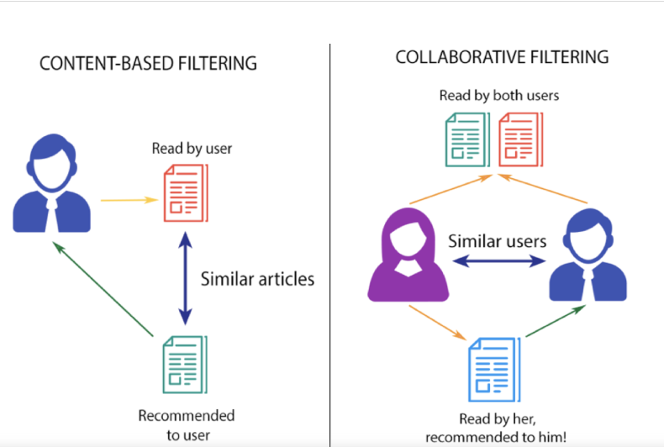



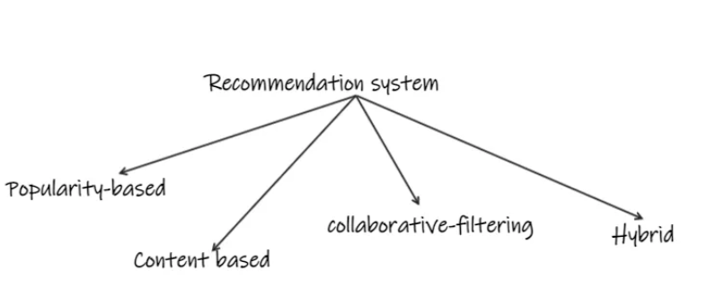

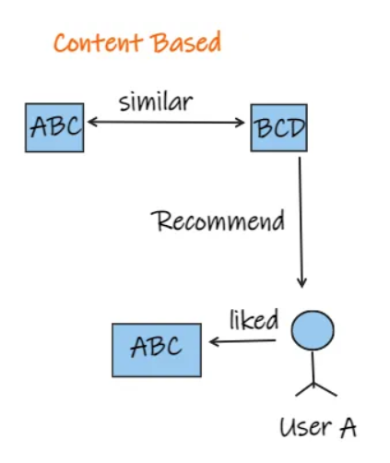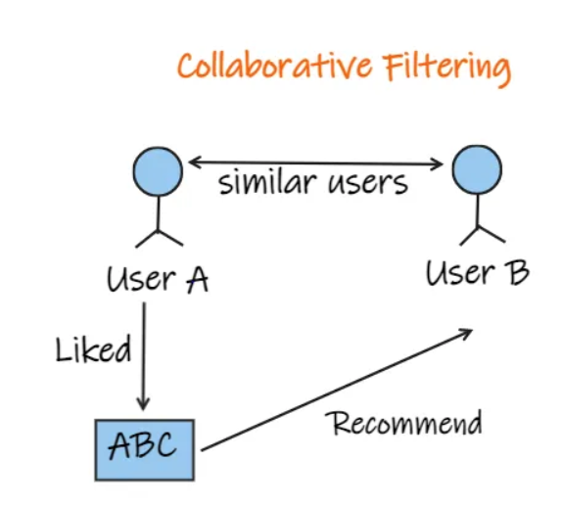

**Demo of the project**

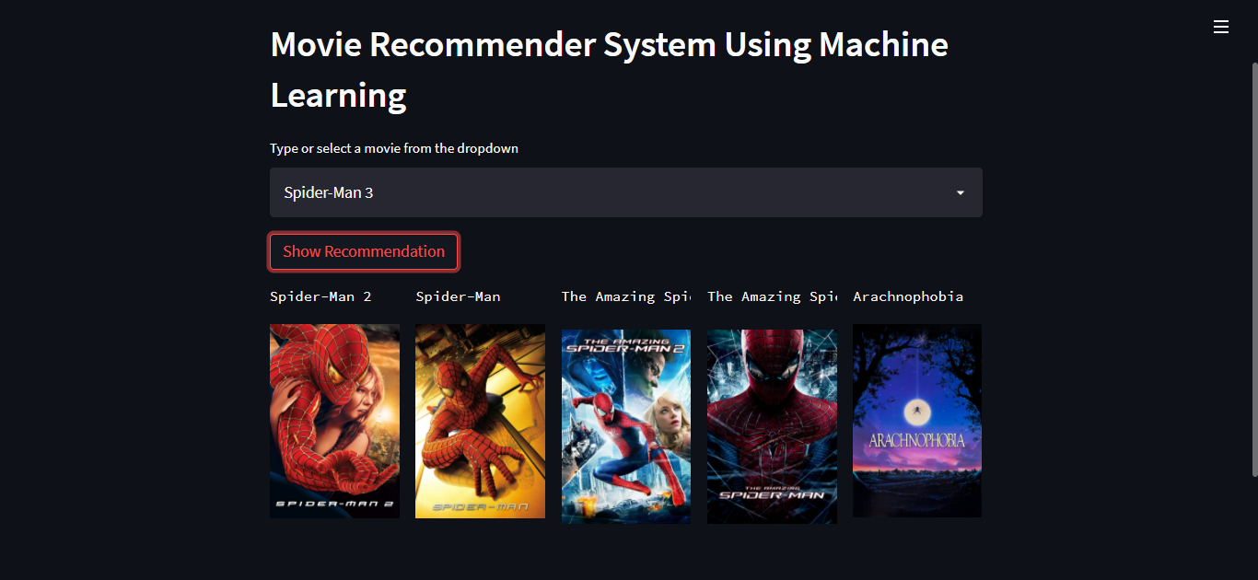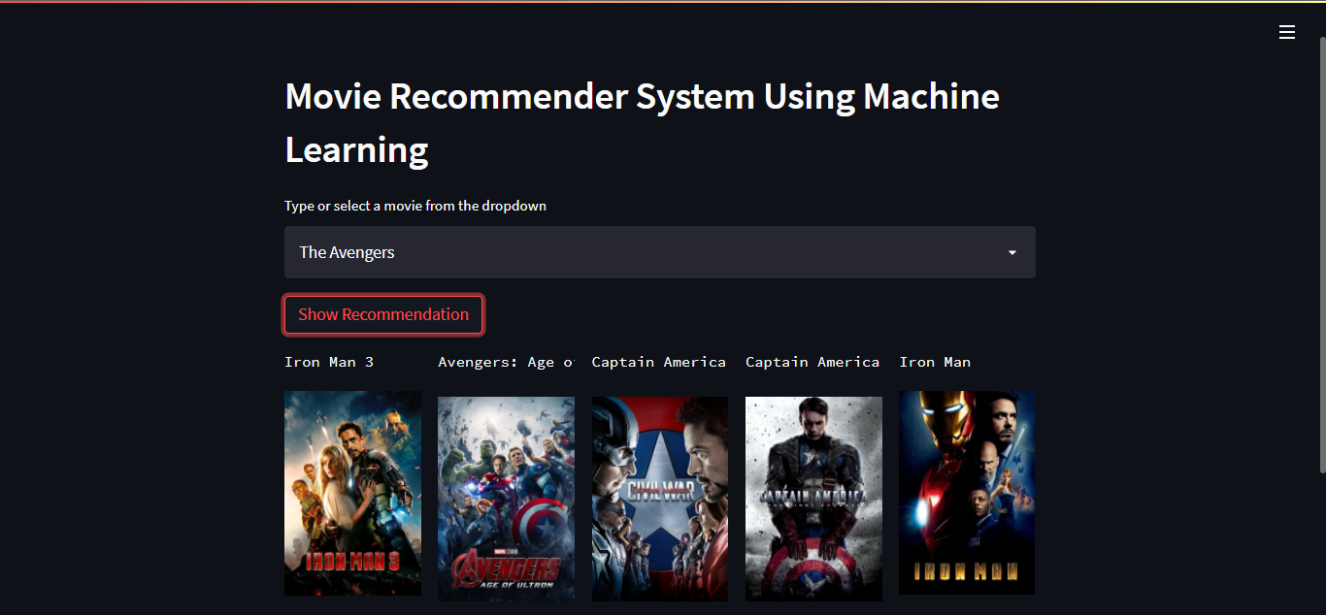

**12. Conclusion**

12.1 Summary of the Project

Summarizes the key points and achievements of the movie recommendation system project.

12.2 Future Enhancements

Suggests potential improvements and features for future iterations of the recommendation system.

13. References

Provides a list of sources and references used in the development of the recommendation system.

This documentation serves as a comprehensive guide for building, deploying, and maintaining a movie recommendation system using machine learning techniques. It covers every aspect of the development process, ensuring that developers and data scientists have a clear roadmap to follow when creating their own recommendation systems.